**User Guide**

Tyler Page

Andrew Anstaett

Austin Waters

Carrie Griffins

Frank Patel

**Customer View**

When the party first sits at the table they will be greeted with the following screen.

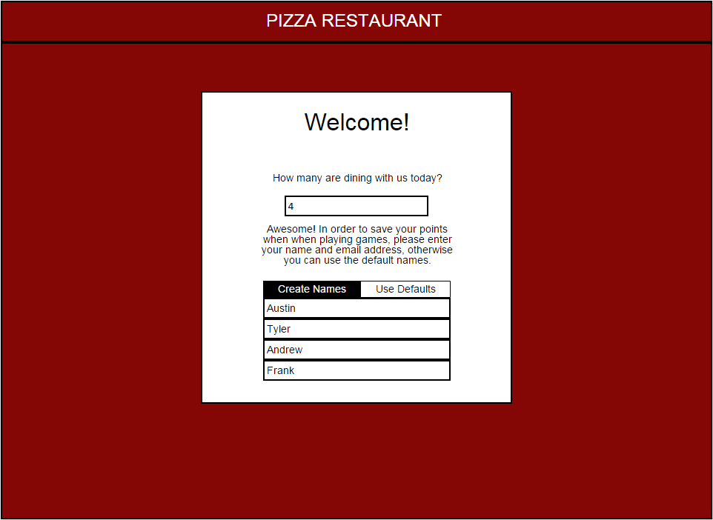

The screen will prompt them for the number of guests in their party. Afterwards, the system will ask if the party wants to provide customized names for the order, or provide them with defaults.

After the party passes the first screen, the system will display the menu with the “Specials” tab preselected to provide emphasis on the restaurant’s specials for the day. The party will then be prompted to order their drinks after the menu displays with this screen:

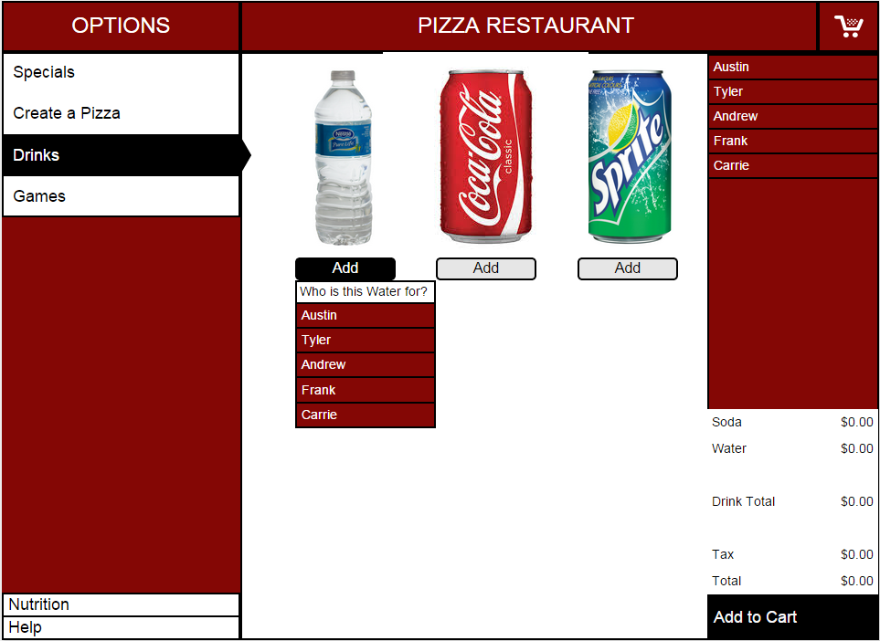

After the drinks are ordered, the refill button will appear and allow the party to ask for refills

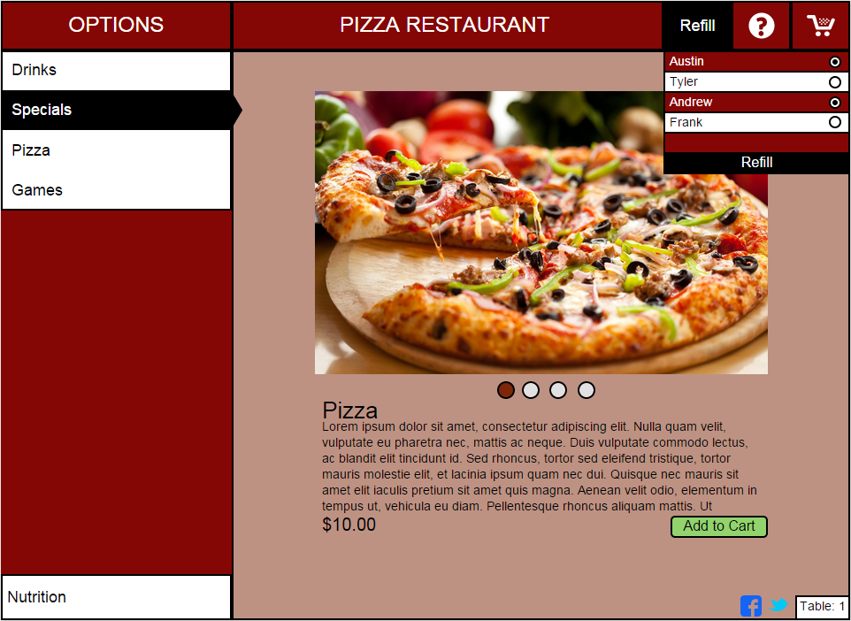

When the party is ready to order, they will press the “Pizza” button to start the customization process of making their pizza. Each stage of the pizza has it’s own screen and creates an overlay on the pizza crust to show what the final product is going to look like.

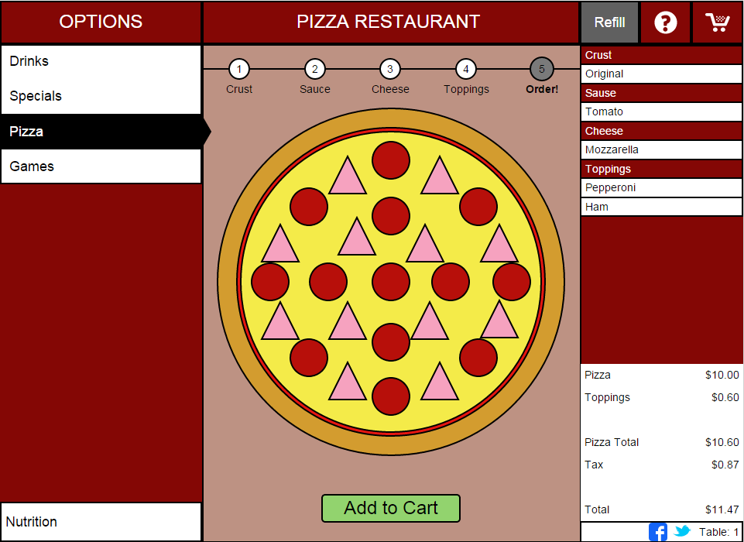

The process repeats for the number of people in the party, with each person pressing “Add to Cart” when finished. After everyone is finished, the user will click the shopping cart icon in the top right corner to confirm the order, choose if the order is for here or to-go, and send the order to the kitchen.

If the customer needs to enter special instructions, there is a button that allows them to do so as well.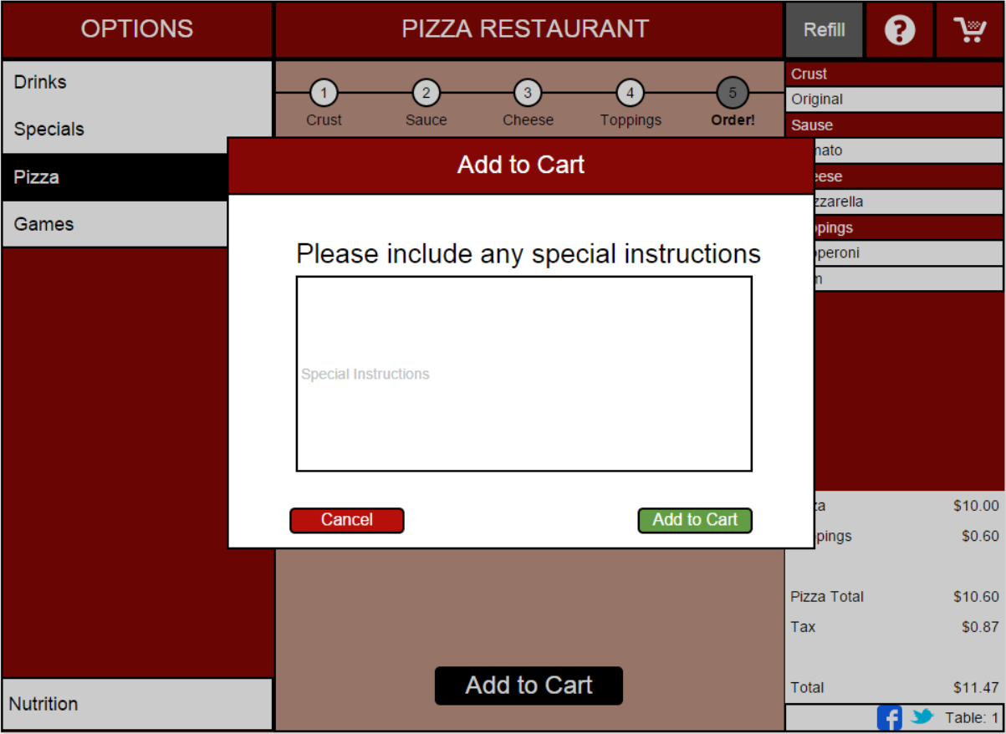

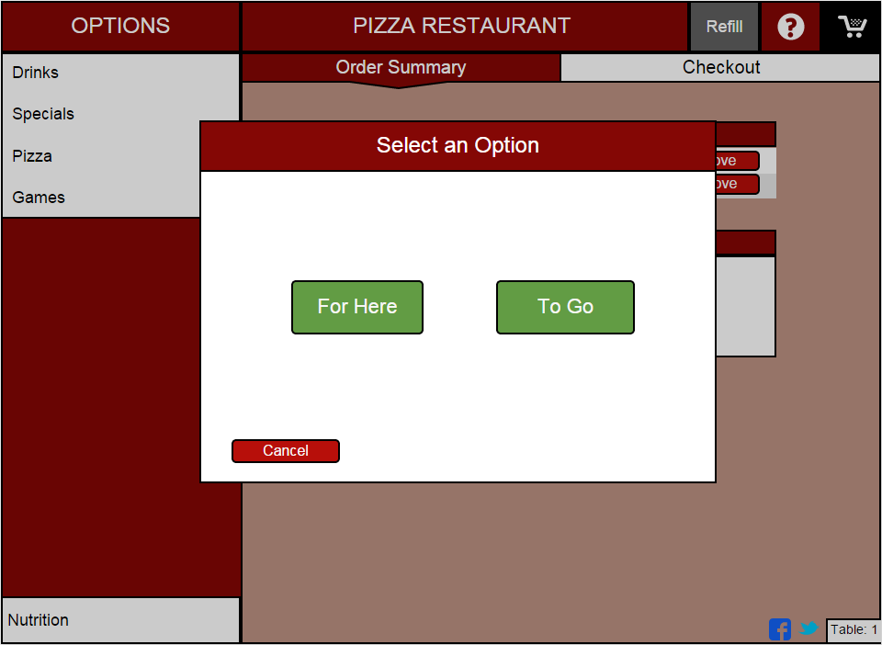

After an order is placed, the “Pizza” tab will display the progress of their order to the customer

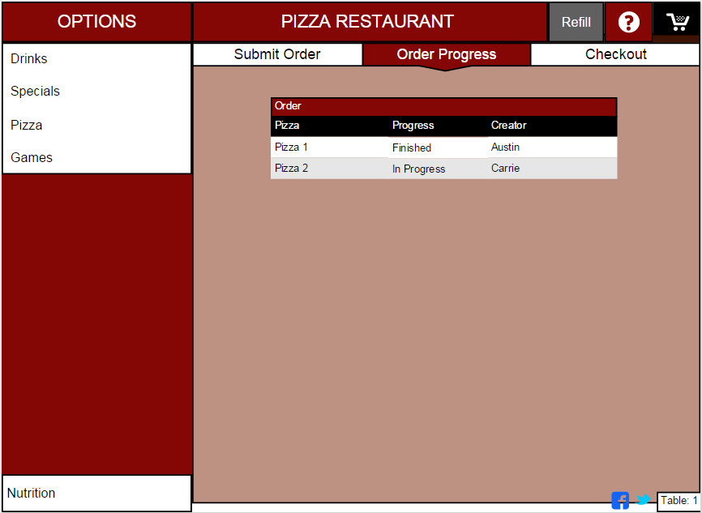

If the customer needs nutritional information for any of the pizzas, they can select the “Nutrition” button in the bottom left hand corner to view nutritional information.

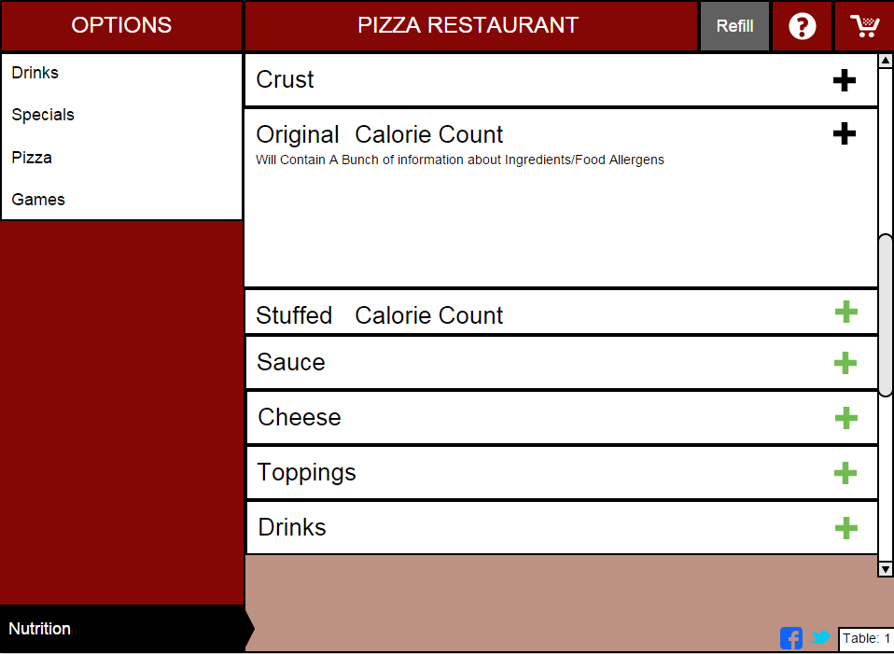

If the customer needs help at any point during the meal, a visible “Help” button will always be displayed on the screen. Pressing this button will alert the wait-staff that their specific table needs assistance.

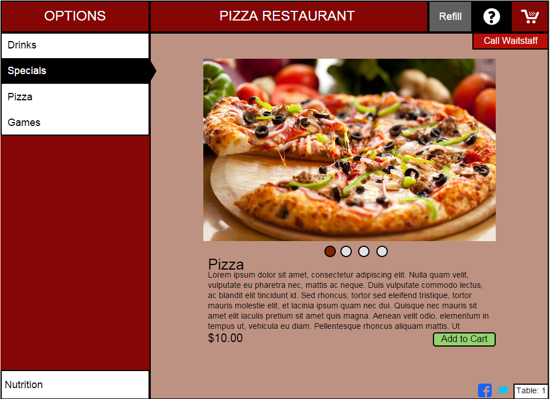

If the customer wants to play games while waiting or for entertainment, they can select the “Games” tab, and it will list the games available to play as well as the option to sign in with their Twitter, Facebook, or email address to track points and get email coupons as rewards.

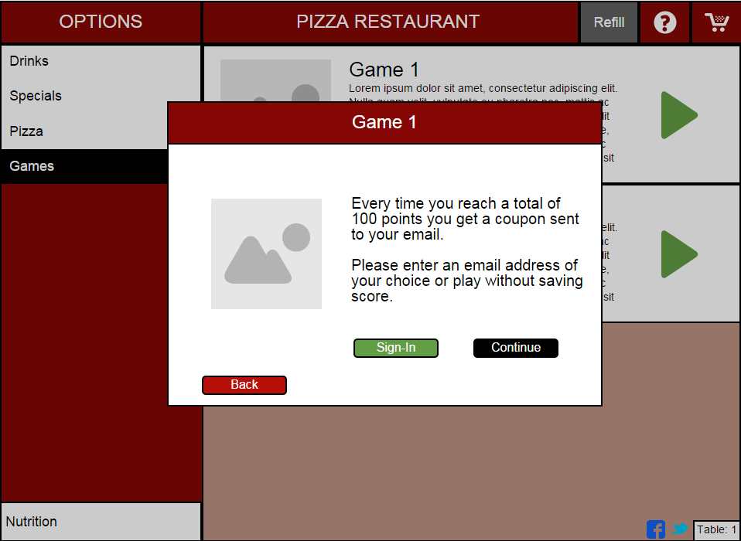

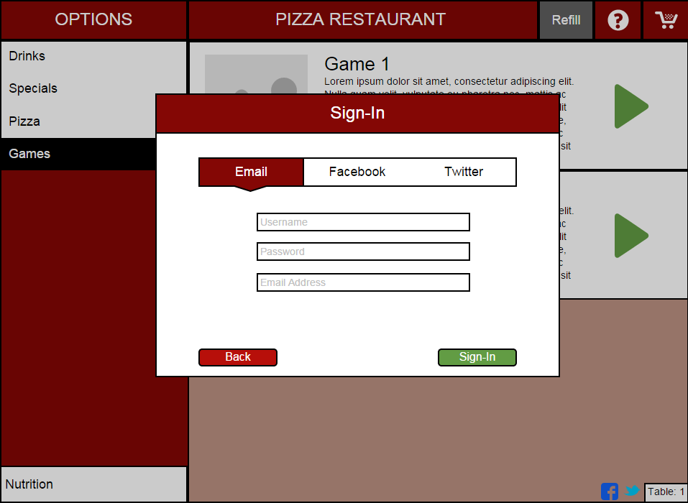

When the customer wants to pay the bill, there will be an option to split the payment or pay all together, then they will be prompted to pay with cash or card.

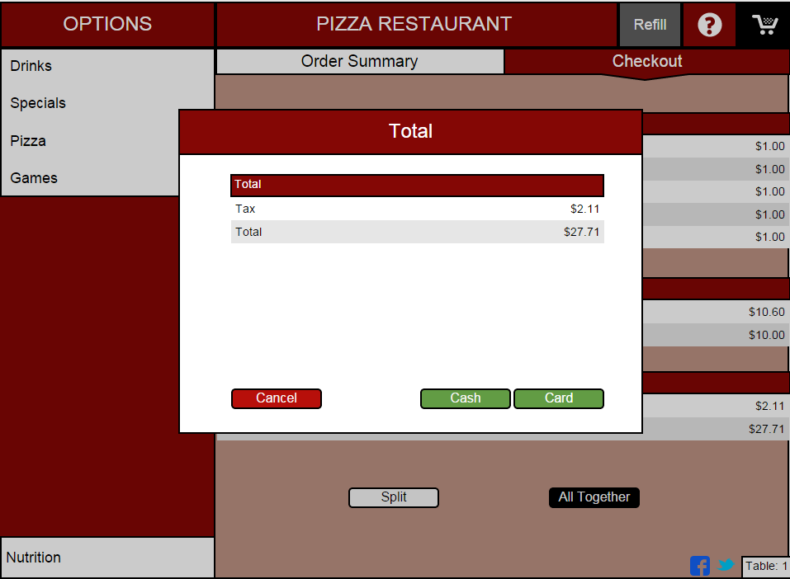

If the customer pays with card, they will have the option to tip a percent of the bill or a flat dollar amount on top of their bill

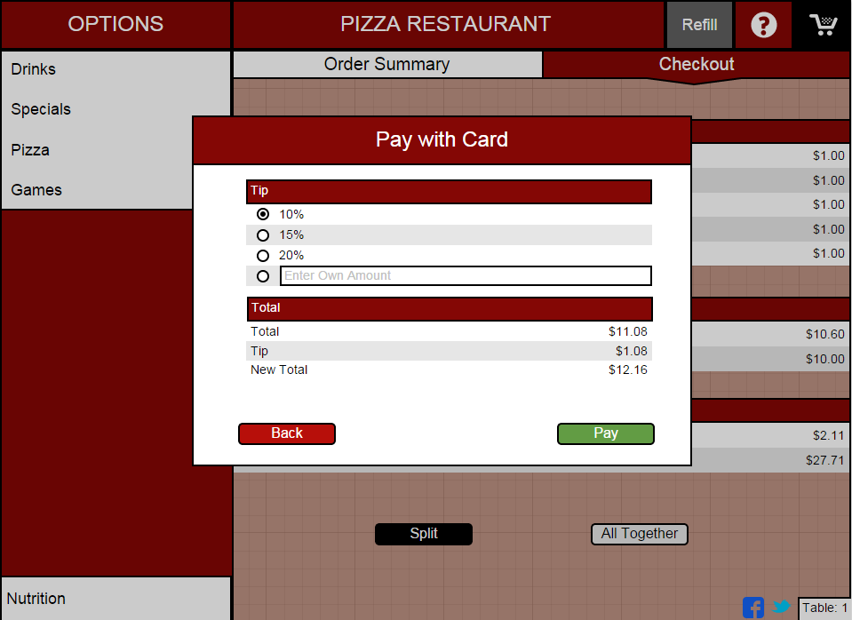

After the customer finishes paying, a pop-up of their receipt will show, and they will be able to choose to have it printed or emailed to them for their records.

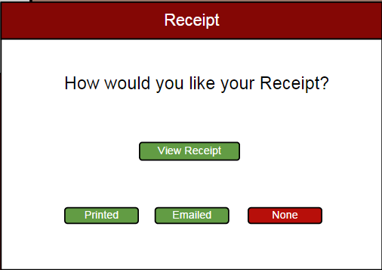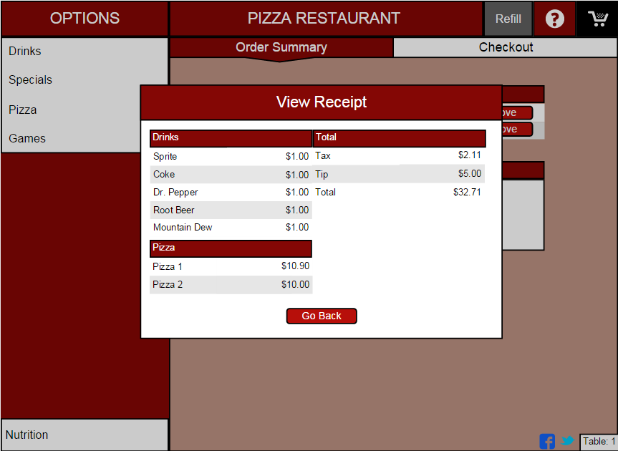

**Kitchen View**

When an order is sent to the kitchen, it is assigned to a cook. The cook sees the order pop-up on a screen like this:

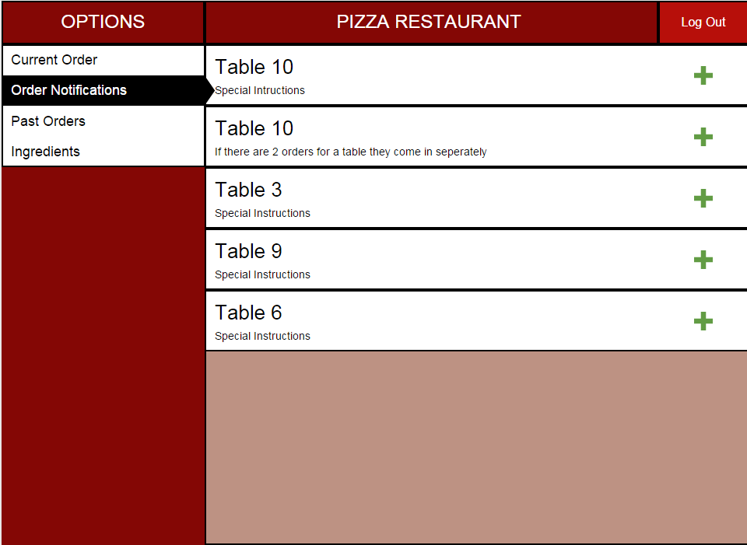

The cook will then be able to begin working on the order. When the order is finished, the cook will be able to press the “Finished” button to complete the order

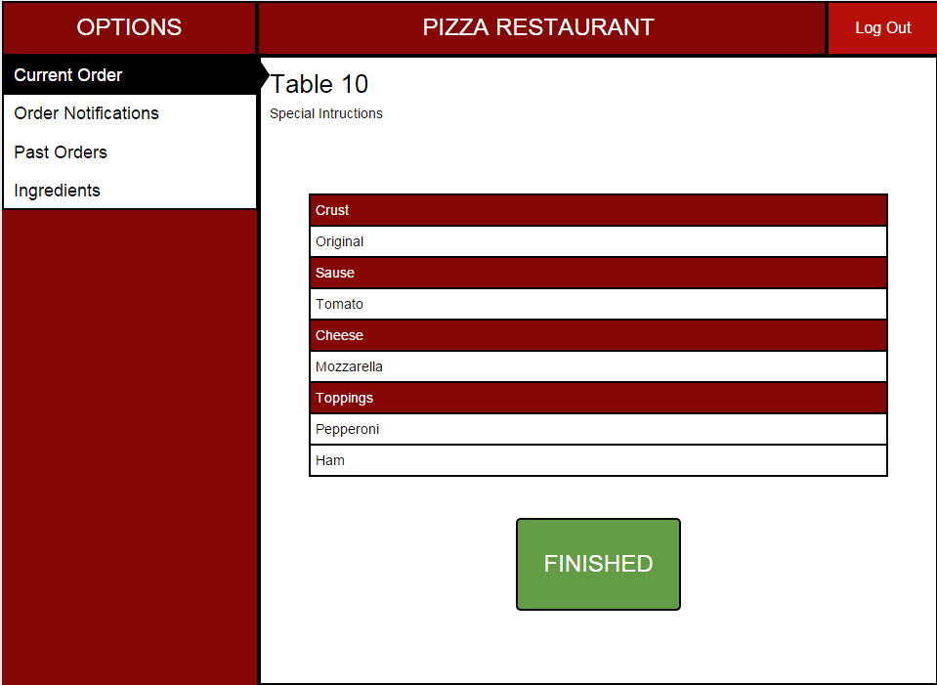

If the kitchen runs out of a certain ingredient, the cooks will be able to remove that ingredient (and every food item that is made with that ingredient) from the menu. As a result, the items that can’t be made because of lacking ingredients, cannot be ordered on the Customer View.

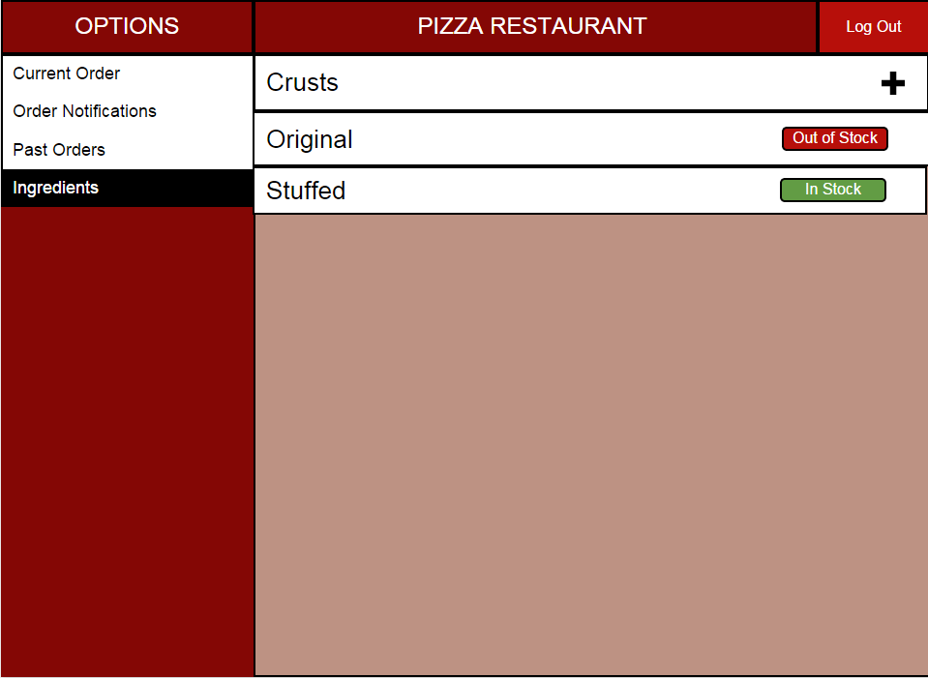

**Administrative View**

When the managers log into the system, they will be greeted with the Administrative view.

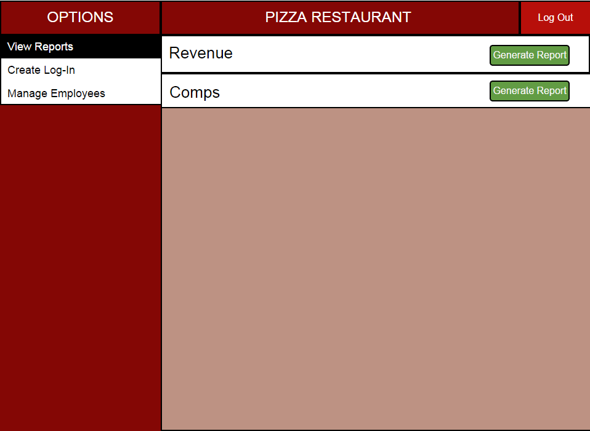

This view will allow managers to access all features of the wait-staff view, as well as an option to generate reports for specific items, and financial details (revenue, comps, etc.). Managers will also be able to create and modify employee login data

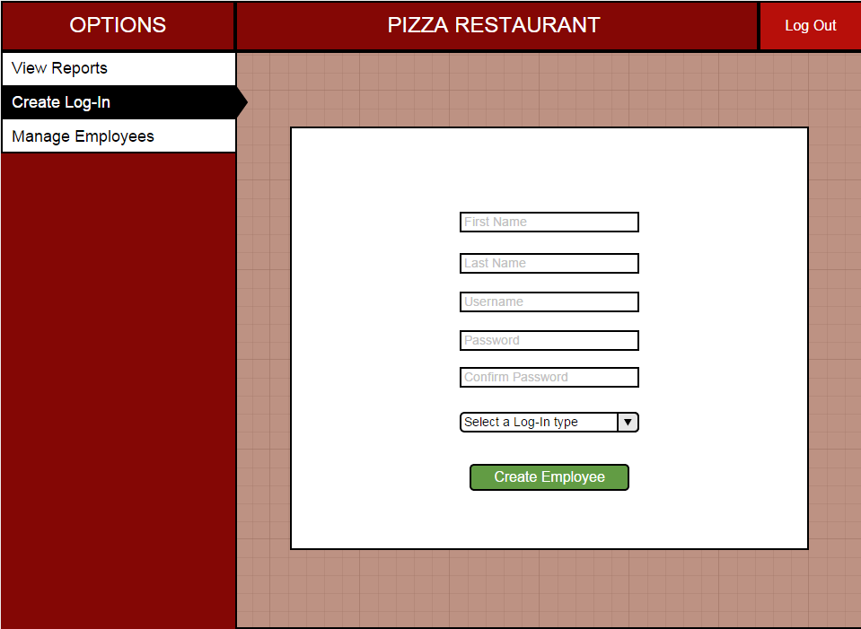

**Wait-staff View**

When servers log into the system with their employee id, they will be greeted with the wait-staff view

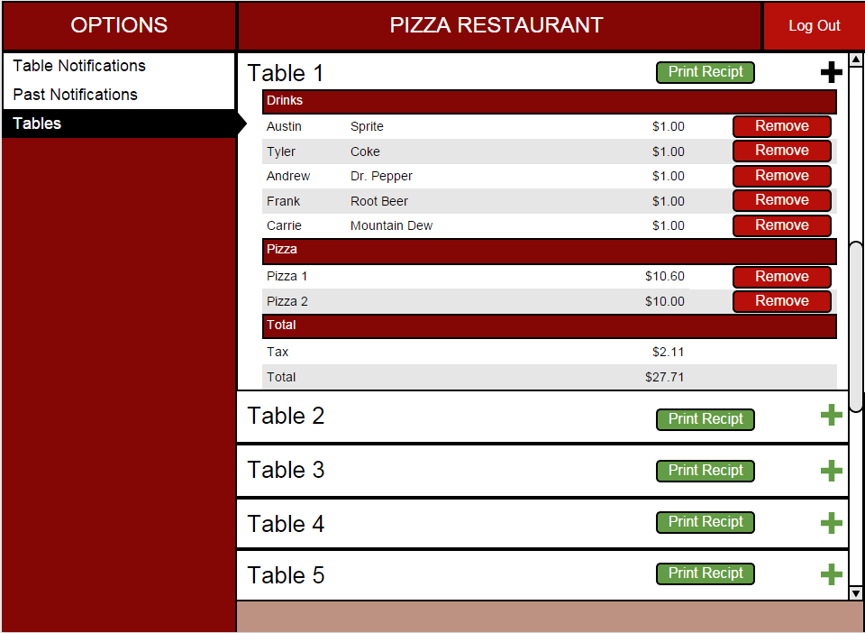

Selecting a table will allow the wait-staff to modify the order.

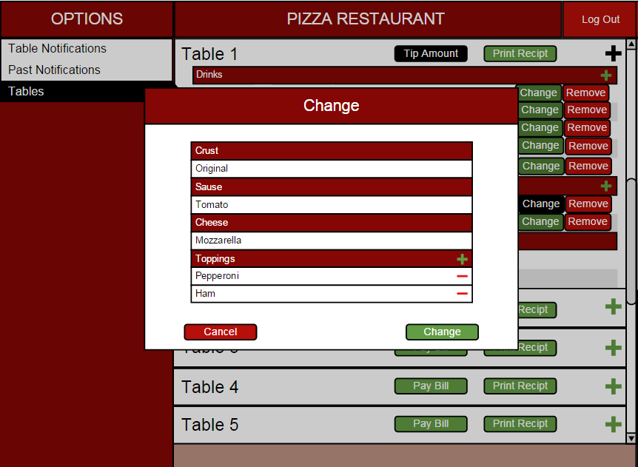

When an order is finished, the wait-staff will be notified that an order is complete and ready to be taken out to the customer

This view will allow wait-staff to comp orders with manager approval

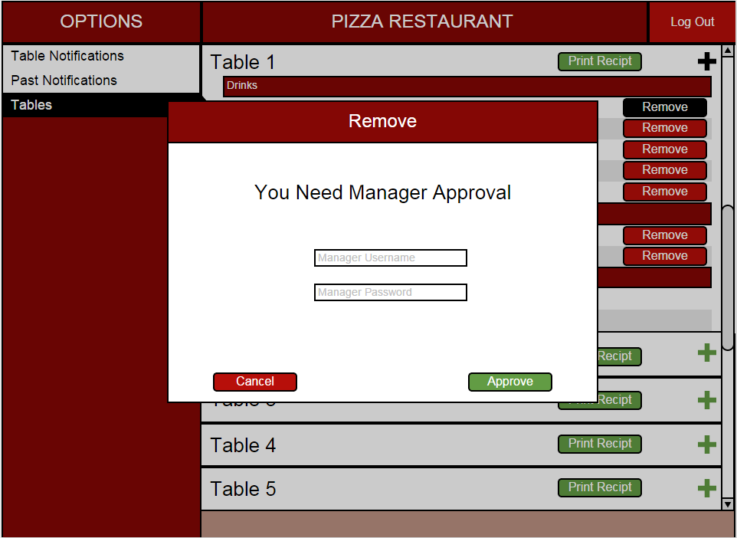

The system will also allow the wait-staff to view table’s orders as well as print the bill or pay the bill for each table.

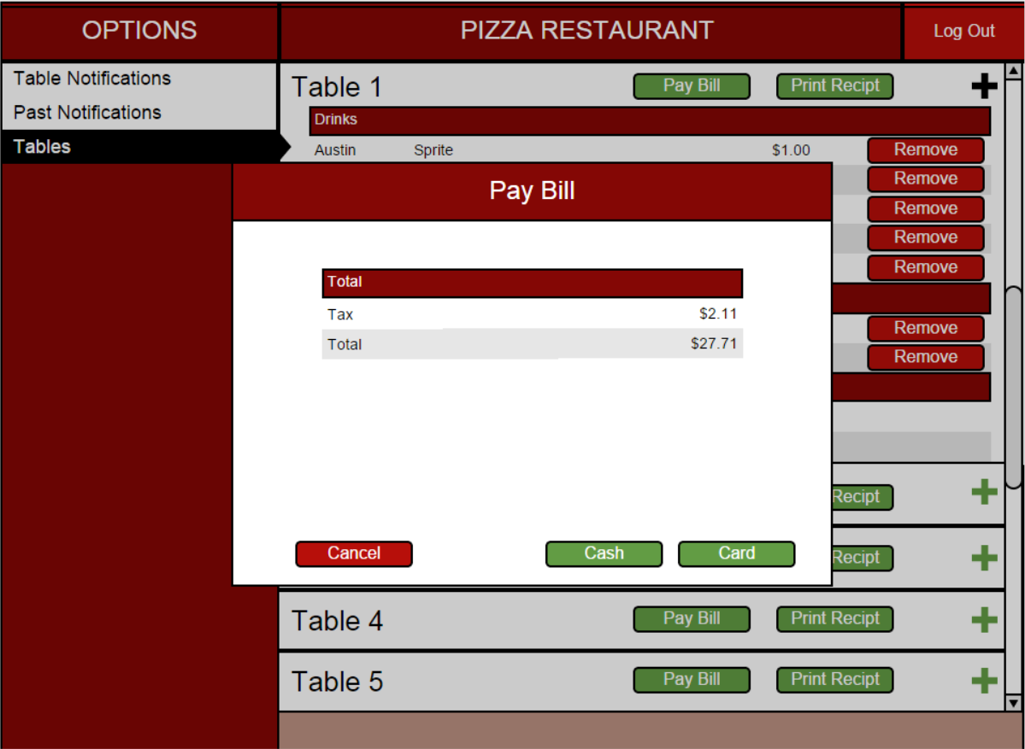

This view will also notify the wait-staff of any possible thing they need to do with their tables. This includes if the table is paying in cash, if a table has paid on the machine, if the table needs a refill, if the order is finished and ready to be taken out, and if their table needs assistance.

